August monthly report
Project Title:
Conversion of post-combustion gas from cement manufacturing to syngas by electrochemical CO₂ capture and reduction
……..........................................................
Dr. Pongkarn Chakthranont
Sothearoth Heng
NCR ID: 803198
Under the supervision of
Dr. Pongkarn Chakthranont
Contract Number: NCR-NN-2023-20170-EN
August 2024

- Tasks list for August
- Catalyst modification:
  - Axial coordination of NiSAC catalyst with triazole derivatives
  - Physical blending of Ni0.5SAC with MOFs
- CO2RR performance measurement of modified catalysts under diluted CO₂ and
- Experimental Procedure
Preparation of Ni0.5SAC@PANI and cathode electrode
Briefly, Ni0.5SAC (150mg) and PANI (15, 50, and 75mg) were mixed in 15ml of IPA to make a dispersion solution. Subsequently, the dispersion solution was sonicated for 2h, followed by overnight stirring at a room temperature. Afterwards, the dispersed Ni0.5SAC@PANI was filtered out, followed by several washing with DI. The solid residue was then overnight dried at 80°C to finally obtain Ni0.5SAC@PANI powder. 150mg of Ni0.5SAC@PANI was added into a 10ml of IPA, followed by adding 381µL of XC-2 binder and sonicating for another hour to make an ink solution. The ink solution was then sprayed onto Sigracet 39BB carbon paper to obtain a mass loading of approx. 0.18 ± 0.1 mg/cm².

Preparation of Ni0.5SAC@MOFs cathode electrode via spray coating method
Briefly, Ni0.5SAC (150mg) and 15mg of different types of MOFs (CALF20, CALF20-dtz-atz, and CALF20-3Mel) were sonically blended in 10ml of IPA and 381μL of XC-2 binder to make a dispersion solution. The ink solution was then sprayed onto Sigracet 39BB carbon paper to obtain a mass loading of approx. 0.18 ± 0.1 mg/cm².

Axial coordination modification of Ni0.5SAC with triazole derivatives
The synthesis of axial coordinated Ni0.5SAC was done by a previous method.¹ Briefly, 150mg of Ni0.5SAC was added into a 50ml round-bottom flask. Afterwards, the large excess of axial ligands (mole ratio of ligand and Ni-SAC of 10:1) dissolved in 10ml DMF was added into the round bottom flask and stirred at 75°C for 24h. After cooling down to room temperature, the precipitate was filtered and washed several times with ethanol. Finally, the precipitate was overnight dried at 80°C to obtain ax-Ni0.5SAC-tz, atz, and dtz powder.

Triazole derivatives: 1,2,4-triazole (tz), 3-diamino-1,2,4-triazole (atz), and 3,5-diamino-1,2,4-triazole (dtz)

Electrochemical CO2RR measurements
A 5 cm² MEA electrolyzer was used to evaluate the CO2RR performance under modulated operating conditions. The Ni foam, bipolar membrane (BPM), and different cathode catalysts were employed as the anode, membrane, and cathode electrode, respectively. 50 ml of 1M KOH was recirculated and used throughout the experiment as the anolyte at 8 ml/min. The humidified 15%CO₂/85%N₂ gas stream was introduced into the cathodic inlet under total flow rates of 100 ml/min. Meanwhile, the cathodic outlet was directly injected into an online gas-chromatography for gas products analysis.

- Results
Influence of physical blending of Ni0.5SAC with polyaniline (PANI) on CO2RR performance under 15%CO₂ condition
As shown in Fig. 1, the modified Ni0.5SAC@PANI exhibited similar results to bare-Ni0.5SAC with a maximum FE(CO) of 73% and highly stable under a diluted 15%CO₂ at 200mA/cm² for 3h.
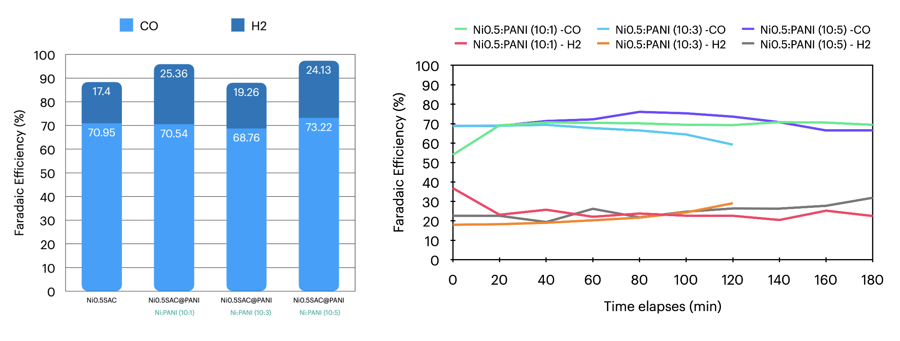
Figure 1. Faradaic efficiency of bare-Ni0.5SAC and Ni0.5SAC@PANI under a diluted CO₂ condition.

Influence of physical blending of Ni0.5SAC and MOFs on CO2RR performance under 15%CO₂ condition
Further studies on the physical blending of Ni0.5SAC and CALF20 derivatives were conducted. As can be seen in Fig. 2, all Ni0.5SAC@MOFs showed poor performance and stability compared to a bare-Ni0.5SAC due to its high-water adsorption under a high humidity environment, thereby causing GDE flooding and high HER activity.
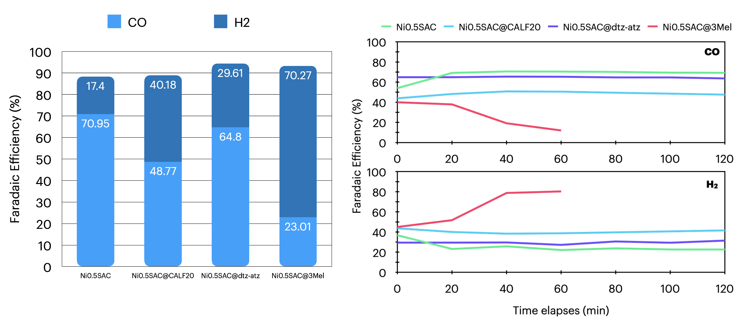
Figure 2. Faradaic efficiency of bare-Ni0.5SAC and Ni0.5SAC@MOFs under a diluted CO₂ condition.

Influence of axial modification of Ni0.5SAC with triazole derivatives on CO2RR under 15%CO₂ condition
Inspired by a few reports demonstrating the enhanced electrochemical CO₂ reduction reaction of axial coordination that could regulate the electronic structure and single-atom catalyst environment to be highly selective toward CO2RR, the axial modification of Ni0.5SAC with triazole derivatives was conducted.^{1–4} As shown in Fig. 3, By increasing the amine functional group of the triazole linker, the CO2RR performance further decreased, which might be attributed to an enhance of hydrophilicity of the catalyst facilitates a competing HER activity over CO2RR.

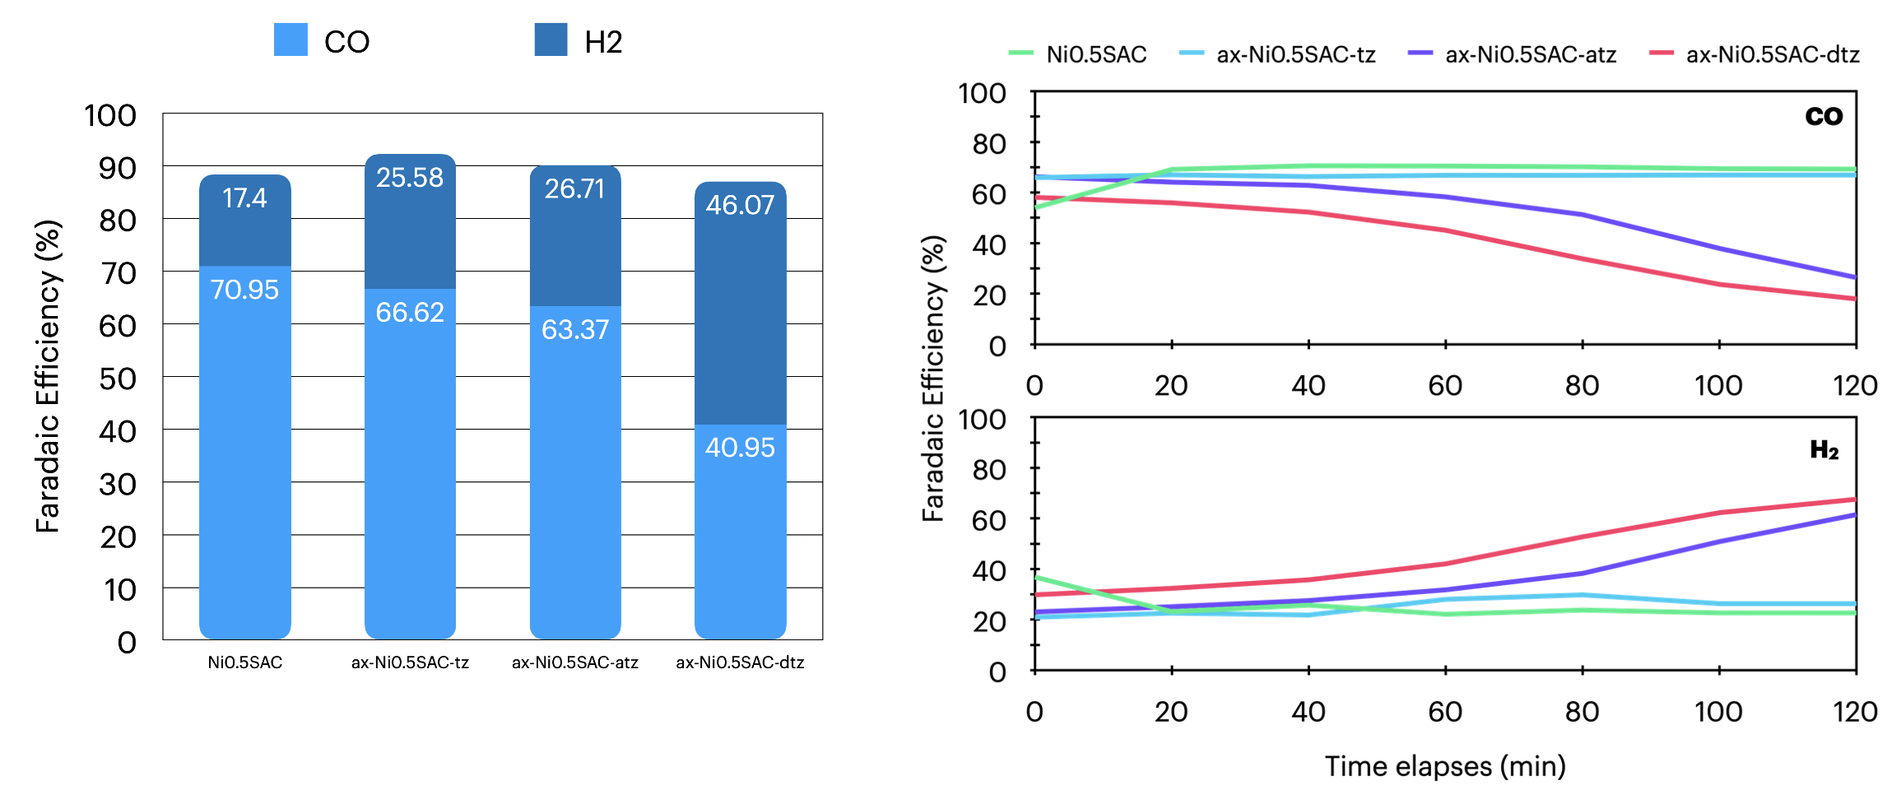
Figure 3. Faradaic efficiency of bare-Ni0.5SAC and ax-Ni0.5SAC under a diluted CO₂ condition.

- Upcoming tasks
- Literature review on developing single atom catalysts.
- CO2RR under NOx and SOx containing CO₂ feed.
- Studies of pulse CO₂ electrolysis under a diluted CO₂ condition.

- References
1. Kang, H. et al. Enhancing CO2 Reduction Efficiency on Cobalt Phthalocyanine via Axial Ligation. ChemCatChem 15, e202300576 (2023).
2. Ma, M. & Tang, Q. Axial coordination modification of M–N4 single-atom catalysts to regulate the electrocatalytic CO2 reduction reaction. J Mater Chem C Mater 10, 15948–15956 (2022).
3. Lv, R., Chen, S. & Wang, H. Axial Coordination Regulating Single Atoms for Enhanced CO2 Electroreduction. ChemElectroChem 11, e202300857 (2024).
4. Liu, X., Liu, Y., Yang, W., Feng, X. & Wang, B. Controlled Modification of Axial Coordination for Transition-Metal Single-Atom Electrocatalyst. Chemistry – A European Journal 28, e202201471 (2022).

